Experiment 1 - Kanban Board using Trello

Aim: To create a Kanban Board for visualizing project tasks using Trello.
Tool Used: Trello
Tasks:
- Create Login Page
- Design Database
- User Registration
- Test Login Module
- Deploy Application
Result:
A Kanban Board was successfully created with To Do, Doing, and Done lists. Tasks were moved across the workflow to simulate project progress.

Initial Screenshot:
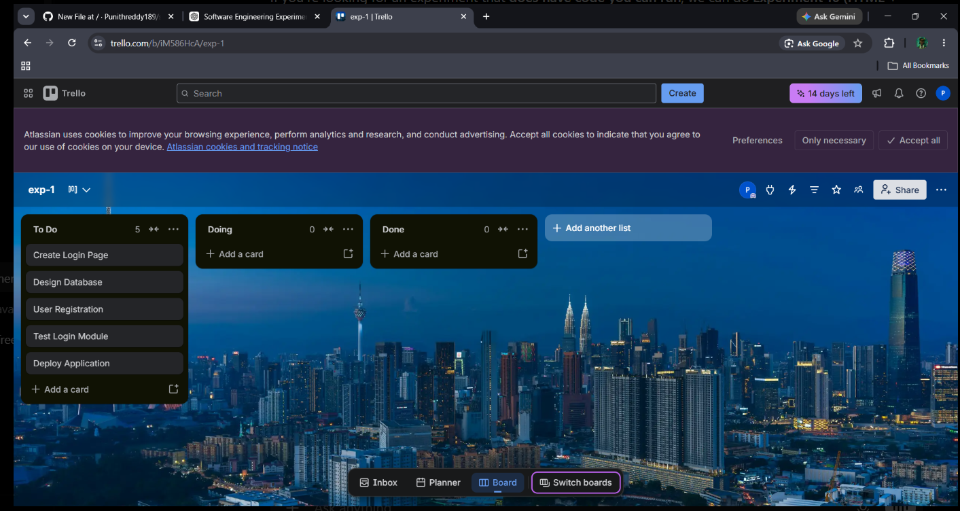

Final Screenshot:
